

**Green University of Bangladesh**

**Department of Computer Science and Engineering (CSE)**

**Faculty of Sciences and Engineering**

**Semester: (Spring, Year:2023), B.Sc. in CSE (Day)**

**Course Title: Object Oriented Programming Lab**

**Course Code: CSE-202 Section: DE**

**Lab Project Name: Tiger Cricket Score Display**

**Student Details**

|  |  |
| --- | --- |
| **Name** | **ID** |
| Md. Moshiur Rahman | 221902324 |

**Submission Date :**

**Course Teacher’s Name :** Dr. Muhammad Aminur Rahaman

**[For Teachers use only: Don’t Write Anything inside this box]**

|  |
| --- |
| **Lab Project Status**  **Marks: ………………………………… Signature: .....................**  **Comments: .............................................. Date: ..............................** |

Table of Contents

Chapter 1 Introduction 3

1.1 Introduction 3

1.2 Design Goals/Objective 3

Chapter 2 Design/Development/Implementation of the Project 4

2.1 Section (Choose the name of this section as appropriate with your project) 4

2.2 Section (Choose the name of this section as appropriate with your project) 4

2.2.1 Subsection 4

Chapter 3 Performance Evaluation 5

3.1 Simulation Environment/ Simulation Procedure 5

3.2 Results and Discussions 5

Chapter 4 Conclusion 6

4.1 Introduction 6

4.1 Practical Implications 6

4.2 Scope of Future Work 6

References 7

# Chapter 1 Introduction

## Introduction

The TigerCricketScoreGUI program is a Java application that provides a graphical user interface (GUI) for entering and calculating the scores of cricket players. It allows users to input the names and scores of 11 cricket players and determine the highest scorer. The program utilizes Java's Swing library to create a GUI window with text fields for entering player names and scores. It also includes a button to trigger the calculation and display of the highest scorer. The calculated result is shown in a label at the top of the GUI window.

## Design Goals/Objective

Specify and discuss the goals of your project.

The objective of the TigerCricketScoreGUI program is to provide a user-friendly graphical interface for calculating and displaying the highest scorer among a group of cricket players. The program aims to achieve the following objectives:

1. Input Player Information: Allow users to enter the names and scores of 11 cricket players using text fields in the GUI. Ensure that the input is accurate and can handle numeric values for scores.
2. Calculate Highest Scorer: Implement a logic to calculate the highest scorer based on the entered scores. Compare the scores of each player and determine the player with the highest score.
3. Display Results: Present the name and score of the highest scorer in a label or text field within the GUI. Ensure that the result is clearly visible and easily readable by the user.
4. User-Friendly Interface: Create an intuitive and visually appealing GUI layout to enhance the user experience. Provide clear instructions and labels for input fields, buttons, and result display.
5. Error Handling: Implement proper error handling mechanisms to handle invalid inputs, such as non-numeric values or empty fields. Display informative error messages to guide the user in correcting their inputs.

# Chapter 2

# Design/Development/Implementation of the Project

## Development phrase

## Create a new Java class, such as "TigerCricketScoreGUI", to encapsulate the functionality of the project.

## Import the necessary Java libraries, such as javax.swing and java.awt, for GUI development.

## Implement the GUI by creating a JFrame window and setting its layout to BorderLayout.

## Create the necessary GUI components, including text fields, labels, and buttons, using appropriate Swing classes.

## Arrange the components within the JFrame using the BorderLayout and GridLayout managers.

## Implement event handling by implementing the ActionListener interface and adding action listeners to relevant components.

## Write code to calculate the highest scorer based on the entered scores and update the result label accordingly..

* + 1. **Subsection**



Figure 2.1: Figure name

## Section (Choose the name of this section as appropriate with your project)

## Subsection

# Chapter 3 Performance Evaluation

## Simulation Environment/ Simulation Procedure

Discuss experimental set up and environment installation needed for the simulation of your outcomes.

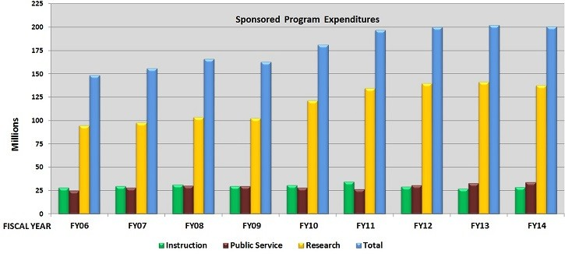

Figure 3.1: Name of figure

## Results and Discussions

* + 1. **Results**
    2. **Analysis and Outcome**

# Chapter 4 Conclusion

## Introduction

Discuss the contents of this chapter and summarized description of the work and the results and observation. Generally, it should be in one paragraph.

## Practical Implications

Discuss the practical implications of the project…

## Scope of Future Work

Discuss the future work of the project...

# References

1. Author Initial. Author Surname, Title. City: Publisher, Year Published, p. Pages Used.
2. A. Rezi and M. Allam, ”Techniques in array processing by means of transforma- tions, ” in Control and Dynamic Systems, Vol. 69, Multidemsional Systems, C. T. Leondes, Ed. San Diego: Academic Press, 1995, pp. 133-180.
3. O. B. R. Strimpel, ”Computer graphics,” in McGraw-Hill Encyclopedia of Science and Technology, 8th ed., Vol. 4. New York: McGraw-Hill, 1997, pp. 279-283.
4. K. Schwalbe, Information Technology Project Management, 3rd ed. Boston: Course Technology, 2004.
5. M. N. DeMers, Fundamentals of Geographic Information Systems, 3rd ed. New York: John Wiley, 2005.
6. M. Bell, et al., Universities Online: A survey of online education and services in Australia, Occasional Paper Series 02-A. Canberra: Department of Education, Science and Training, 2002.